04.03 Entering data

We want to be able to input data to our GUI programs. The Entry widget is a field on the GUI that allows a user to type in a single line of string data. It is created just like the Label and Button widgets, using a tkinter function, Entry.

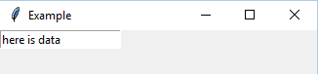
For example,
user_data = tkinter.Entry (window)
user_data.place (x = 0, y= 0)

creates a default sized entry widget. The user typed in the phrase “here is data”.

The data is retrieved using the *.get() command, which retrieves string data from the entry widget much like input() does with the CLI (but *.get() does not stop the program’s flow of control).

So, with the screen example above, the statement
user_input = user_data.get()

is used to take “here is data” from the entry field and assigns it to the variable user_input.

An application may want to start up with a default value in the entry field (otherwise it shows as blank). Use the *.insert (-1, “default data”) statement after the *.place() statement to have default data show up in the entry field when the program starts.

Useful parameters for the Entry widget are as follows (note: some of these are also useful with other widgets, in particular “anchor” in anything that holds text like labels and buttons)

Option | Action
bg | Changes the colour of the background.
fg | Changes the colour of the foreground, or text.
show | Normally, the entry field displays exactly what the user types. However, using show=”*” (or any other character), the entry field only displays that specified character. This is useful for hiding what the user is entering.
cursor | Changes the cursor to the indicated pattern when the cursor is over the entry field. The following are acceptable patterns : “arrow”, “mouse”, “dot”.
font | Change the font of the text in the entry field. See Labels.
justify | Specifies the justification of the string in the entry field. The following are acceptable values: “right”, “left”,”center”
width | Specifies how many characters wide the entry field should appear. The user can enter more characters than that specified by the width.
height | Specifies how many characters high the entry field should appear.
anchor | Indicates within the entry field (or button, or other widgets) where the text will appear using the keywords n, ne, e, se, s, sw, w, nw and center (see below)
  nw n ne
  w center e
  sw s se

See 04.03_example_data_entry.py for a full example.

The program creates a GUI where the user enters their name in the entry field “user_name”. Nothing happens until the user presses the button “Click on Me”. When pressed the event handler function hello_message retrieves the name from the entry field using the *.get () statement, then displays a message in the message_result label using the retrieved name.

Also, an Exit button is added to allow the user to exit the function from the GUI. The button calls the exit() function to end the program.

Interface “states”

Recall the sample GUI below. Now suppose the three long rectangles on the left are entry fields, and the one long rectangle on the right is a label.

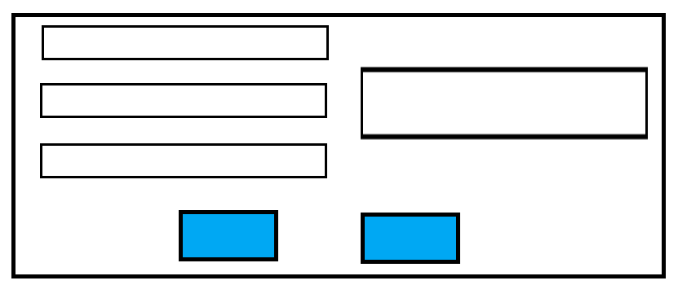

If the buttons get input from the entry fields, the programmer must keep in mind “what if the user leave a field blank”, or “what if they did not fill in the fields in a certain order”?. Generally, the flow of control of the statements in the event handlers can not assume the user filled in the widgets in a particular pattern, they have to deal with the widgets as a snap shot of input, or a given state of the GUI.

Exercises 04.03 Entering data

04.03.01
Write a program that allows the user to input two integers. Add a button that will multiply the integers together.

04.03.02
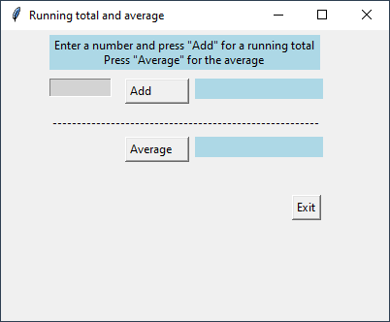
Write a program that allows the user to input a number then press a button to add the number to a running total. The running total will be displayed each time the button is pushed.
Note: How do you account for the very first number to add?
Add a second button that calculates the average of all the numbers entered. Round the average to the nearest 5th decimal.

The GUI should look similar to the example on the right.

04.03.03
Write a program that allows the user to enter a number of coins in the denominations 1, 5, 10 and 25 cents. Add a button which displays i) the total number of coins, and ii) the dollar value of all the coins. After displaying the calculations, clear the entry fields.
Note: Add all the proper commenting in this program.

04.03.04
Write a calculator program that has 2 entry fields, and several buttons to perform multiplication, division, integer division, addition, subtraction, modulus, and exponentiation. For division, integer division and modulus, use the first field as the dividend (the number to be divided). For exponentiation, use the first field as the base, and the second as the exponent.
The user enters values in the 2 entry fields, then presses one of the mathematics operation buttons. The result will appear in a label.

